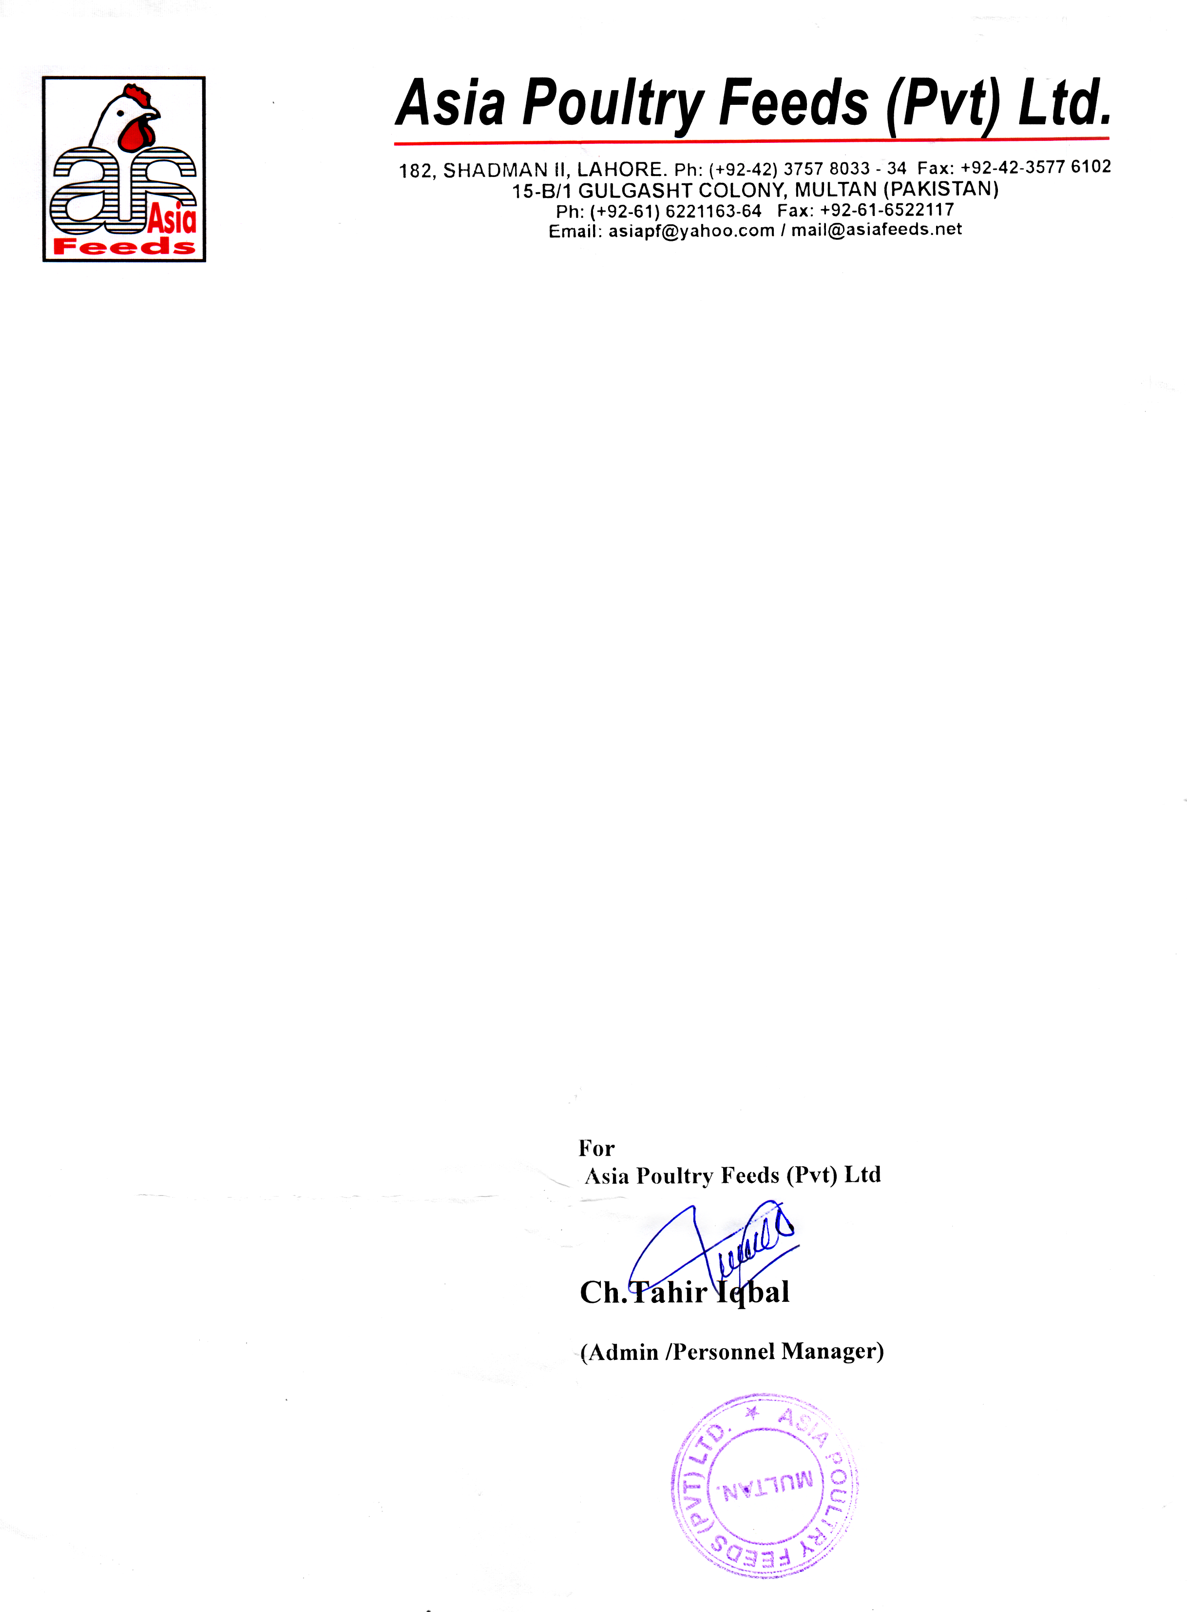

**Date: <To2>**

**TO WHOM IT MAY CONCERN**

This is certified that Mr. <Name> S/O <fname> has employed by Asia Poultry Feeds (Pvt.) Limited Multan from <From2> to   
<To2> as a <Designation>.

This certificate is issued to him as the Company’s way of expressing recognition and appreciation for this exceptional performance on carrying out his assigned duties and responsibilities. The Company is extending to him the best wishes for the future.